**Documentation For Puf-Finder Website**

**1. Introduction**

* **Purpose**: The Dog Adoption website (Puf-Finder) aims to facilitate the adoption of dogs by showcasing available dogs, providing information about the adoption process, and connecting potential adopters with the community.
* **Scope**: The website will include information about the organization, featured dogs available for adoption, adoption guidelines, success stories, and contact information.

**2. Design and Layout**

* **Homepage**:
  + Header with logo and navigation
  + Featured dog section with carousel or grid layout
  + About DAG section with a brief overview and mission statement
  + Adoption process overview with steps or infographic
  + Contact form or information with map location
* **Adoption Page**:
  + List of available dogs in a grid or list format with thumbnail images
  + Clickable dog profiles leading to detailed pages with more information
* **About Us Page**:
  + Detailed mission statement and history of the organization
  + Profiles and photos of key team members or volunteers
  + Success stories and testimonials from adopters

**2.2 Color Scheme and Fonts**

* **Color Scheme**: Use warm and inviting colors such as shades of blue, green, and orange to create a friendly and caring atmosphere.
* **Fonts**: Choose readable fonts for both headings and body text. Examples include sans-serif fonts like Roboto or Open Sans for clean readability.

**3. Technologies Used**

* **Frontend**:
  + HTML5 for structure
  + CSS for styling
  + JavaScript for interactive elements and form validation

**4. Navigation Structure**

* **Header Navigation**:
  + Home
  + Adoption
  + About Us
  + Sign Up
  + Sign In

**5. Functionality**

* **Homepage**:
  + Display featured dogs dynamically, possibly with random selection or based on adoption urgency
  + Interactive adoption process overview with clickable steps
* **Adoption Page**:
  + Dynamic filtering of dogs based on user preferences (e.g., age, breed, size)
  + Detailed dog profiles with photos, descriptions
* **About Us Page**:
  + Compelling storytelling about the organization's mission and impact
  + Integration of success stories with photos and quotes from adopters

**6. Output:**

**6.1 Home Page**

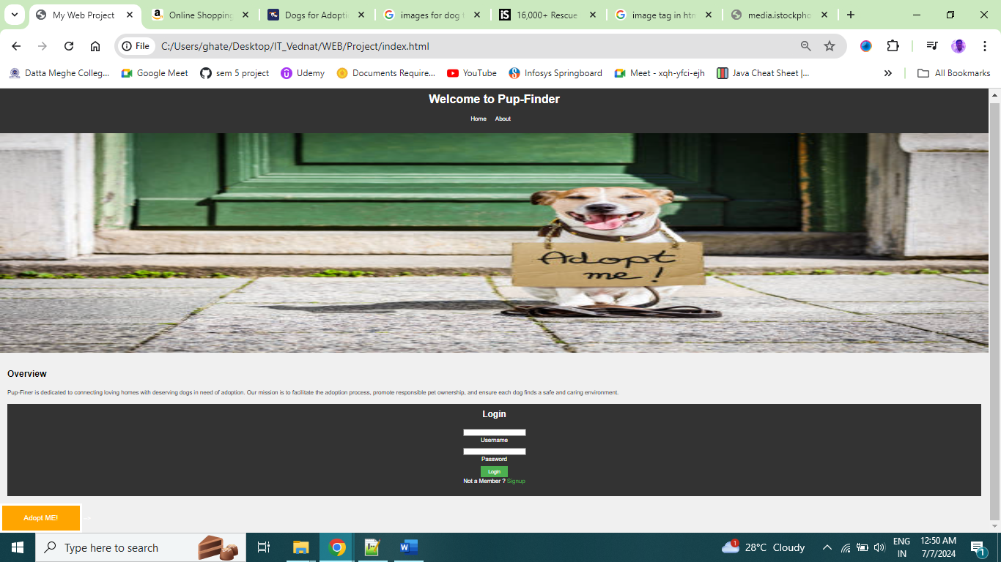

**6.2 About US**

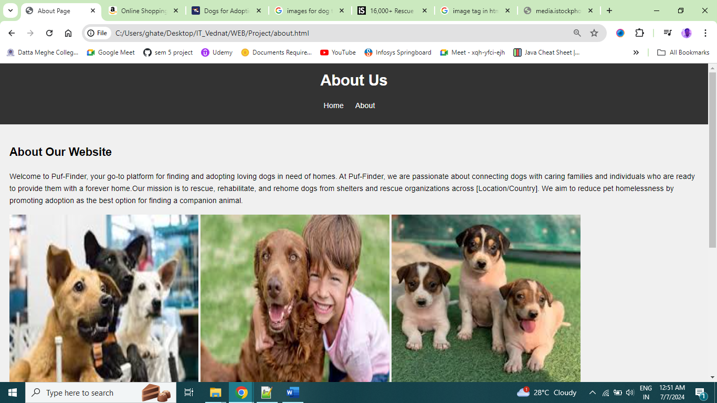

**6.3 Sign Up**

